- Evaluate the derivative below.
$$\frac{d}{dx}(\frac{2}{3}x^{3}+πx^{2}+7x+1)$$

- By applying implicit differentiation, find y'(x) below.
$$y\sqrt{x^{2}+y^{2}}=15$$

- Assume a rectangular flower garden (see figure below) with an area of 32 ft2 is surrounded by a grass border that is 1 ft wide on two sides and 2 ft wide on the other two sides. What dimensions of the garden minimize the combined area of the garden and borders?
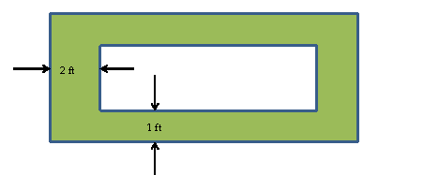

- Find the critical points of the function below. Categorize them as either absolute or local extrema.
$f\left(x\right)=2x^{3}-3x^{2}-36x+12$ for all values of x

- Assume that the initial (at t = 0) population of a prairie dog community is P(0) = 55 dogs. The community population grows at the rate of P'(t) = 20-t/5 for 0 ≤ t ≤ 200 months. Calculate the population 10 months later (including the initial count).

- Find the area bound by two function below.
$$y=x^{2}-2x+1y=5x-9$$

